



Receive and place in-coming phone calls
D1.HFO.CL2.09
Trainee Manual





Receive and place in-coming phone calls

D1.HFO.CL2.09

Trainee Manual





Project Base
William Angliss Institute of TAFE
555 La Trobe Street
Melbourne 3000 Victoria
Telephone: | (03) 9606 2111
Facsimile: | (03) 9670 1330
Acknowledgements
Project Director: | Wayne Crosbie
Chief Writer: | Alan Hickman
Subject Writers: | Evelyn Collins Linda Wilson
Project Manager/Editor: | Alan Maguire
DTP/Production: | Daniel Chee, Mai Vu, Jirayu Thangcharoensamut, Kaly Quach

The Association of Southeast Asian Nations (ASEAN) was established on 8 August 1967. The Member States of the Association are Brunei Darussalam, Cambodia, Indonesia, Lao PDR, Malaysia, Myanmar, Philippines, Singapore, Thailand and Viet Nam.
The ASEAN Secretariat is based in Jakarta, Indonesia.
General Information on ASEAN appears online at the ASEAN Website: www.asean.org.
All text is produced by William Angliss Institute of TAFE for the ASEAN Project on “Toolbox Development for Front Office, Food and Beverage Services and Food Production Divisions”.
This publication is supported by the Australian Government’s aid program through the ASEAN-Australia Development Cooperation Program Phase II (AADCP II).
Copyright: Association of Southeast Asian Nations (ASEAN) 2013.
All rights reserved.
Disclaimer
Every effort has been made to ensure that this publication is free from errors or omissions. However, you should conduct your own enquiries and seek professional advice before relying on any fact, statement or matter contained in this book. The ASEAN Secretariat and William Angliss Institute of TAFE are not responsible for any injury, loss or damage as a result of material included or omitted from this course. Information in this module is current at the time of publication. Time of publication is indicated in the date stamp at the bottom of each page.
Some images appearing in this resource have been purchased from stock photography suppliers Shutterstock and iStockphoto and other third party copyright owners and as such are non-transferable and non-exclusive. Clip arts, font images and illustrations used are from the Microsoft Office Clip Art and Media Library. Some images have been provided by and are the property of William Angliss Institute.
Additional images have been sourced from Flickr and SXC and are used under Creative Commons licence: http://creativecommons.org/licenses/by/2.0/deed.en
File name: TM_Receive_&_place_incoming_calls_refined.docx





Table of contents
Introduction to trainee manual 1
Unit descriptor 3
Assessment matrix 5
Glossary 7
Element 1: Identify elements and facilities of the host enterprise telephone system 9
Element 2: Demonstrate appropriate telephone communication skills 17
Element 3: Receive incoming calls 27
Element 4: Re-direct incoming calls 39
Presentation of written work 43
Recommended reading 45
Trainee evaluation sheet 47
Trainee self-assessment checklist 49

Introduction to trainee manual

To the Trainee
Congratulations on joining this course. This Trainee Manual is one part of a ‘toolbox’ which is a resource provided to trainees, trainers and assessors to help you become competent in various areas of your work.
The ‘toolbox’ consists of three elements:
- A Trainee Manual for you to read and study at home or in class
- A Trainer Guide with Power Point slides to help your Trainer explain the content of the training material and provide class activities to help with practice
- An Assessment Manual which provides your Assessor with oral and written questions and other assessment tasks to establish whether or not you have achieved competency.
The first thing you may notice is that this training program and the information you find in the Trainee Manual seems different to the textbooks you have used previously. This is because the method of instruction and examination is different. The method used is called Competency based training (CBT) and Competency based assessment (CBA). CBT and CBA is the training and assessment system chosen by ASEAN (Association of South-East Asian Nations) to train people to work in the tourism and hospitality industry throughout all the ASEAN member states.
What is the CBT and CBA system and why has it been adopted by ASEAN?
CBT is a way of training that concentrates on what a worker can do or is required to do at work. The aim is of the training is to enable trainees to perform tasks and duties at a standard expected by employers. CBT seeks to develop the skills, knowledge and attitudes (or recognise the ones the trainee already possesses) to achieve the required competency standard. ASEAN has adopted the CBT/CBA training system as it is able to produce the type of worker that industry is looking for and this therefore increases trainees chances of obtaining employment.
CBA involves collecting evidence and making a judgement of the extent to which a worker can perform his/her duties at the required competency standard. Where a trainee can already demonstrate a degree of competency, either due to prior training or work experience, a process of ‘Recognition of Prior Learning’ (RPL) is available to trainees to recognise this. Please speak to your trainer about RPL if you think this applies to you.
What is a competency standard?
Competency standards are descriptions of the skills and knowledge required to perform a task or activity at the level of a required standard.
242 competency standards for the tourism and hospitality industries throughout the ASEAN region have been developed to cover all the knowledge, skills and attitudes required to work in the following occupational areas:
- Housekeeping
- Food Production
- Food and Beverage Service
- Front Office
- Travel Agencies
- Tour Operations.
All of these competency standards are available for you to look at. In fact you will find a summary of each one at the beginning of each Trainee Manual under the heading ‘Unit Descriptor’. The unit descriptor describes the content of the unit you will be studying in the Trainee Manual and provides a table of contents which are divided up into ‘Elements’ and ‘Performance Criteria”. An element is a description of one aspect of what has to be achieved in the workplace. The ‘Performance Criteria’ below each element details the level of performance that needs to be demonstrated to be declared competent.
There are other components of the competency standard:
- Unit Title: statement about what is to be done in the workplace
- Unit Number: unique number identifying the particular competency
- Nominal hours: number of classroom or practical hours usually needed to complete the competency. We call them ‘nominal’ hours because they can vary e.g. sometimes it will take an individual less time to complete a unit of competency because he/she has prior knowledge or work experience in that area.
The final heading you will see before you start reading the Trainee Manual is the ‘Assessment Matrix’. Competency based assessment requires trainees to be assessed in at least 2 – 3 different ways, one of which must be practical. This section outlines three ways assessment can be carried out and includes work projects, written questions and oral questions. The matrix is designed to show you which performance criteria will be assessed and how they will be assessed. Your trainer and/or assessor may also use other assessment methods including ‘Observation Checklist’ and ‘Third Party Statement’. An observation checklist is a way of recording how you perform at work and a third party statement is a statement by a supervisor or employer about the degree of competence they believe you have achieved. This can be based on observing your workplace performance, inspecting your work or gaining feedback from fellow workers.
Your trainer and/or assessor may use other methods to assess you such as:
- Journals
- Oral presentations
- Role plays
- Log books
- Group projects
- Practical demonstrations.
Remember your trainer is there to help you succeed and become competent. Please feel free to ask him or her for more explanation of what you have just read and of what is expected from you and best wishes for your future studies and future career in tourism and hospitality.

Unit descriptor
Receive and place in-coming phone calls
This unit deals with the skills and knowledge required to Receive and place in-coming phone calls in a range of settings within the hotel and travel industries workplace context.
Unit Code:
D1.HFO.CL2.09
Nominal Hours:
15 hours

Element 1: Identify elements and facilities of the host enterprise telephone system
Performance Criteria
1.1 Identify the types of incoming calls that may be received and their importance to the business
1.2 Identify the components of the telephone system
1.3 Describe the functions and features available in the telephone system

Element 2: Demonstrate appropriate telephone communication skills
Performance Criteria
2.1 Interpret the enterprise policies and procedures for telephone use in regard to incoming calls
2.2 Explain the importance of first impressions in relation to telephone answering and the reputation of the business
2.3 Differentiate between face-to-face and over-the-phone communications
2.4 Use appropriate telephone communication skills
2.5 Use appropriate telephone techniques
2.6 Describe acceptable telephone etiquette
2.7 Identify common caller complaints about telephoning a business

Element 3: Receive incoming calls
Performance Criteria
3.1 Prepare to receive incoming calls
3.2 Answer calls promptly in accordance with house standards
3.3 Identify long-distance or international calls
3.4 Establish purpose of incoming calls
3.5 Respond to caller requests, where appropriate
3.6 Take messages from callers
3.7 Relay messages and follow-up as necessary
3.8 Facilitate conference calls
3.9 Deal with suspicious or threatening calls
3.10 Manage difficult callers
3.11 Prepare voicemail messages and background music

Element 4: Re-direct incoming calls
Performance Criteria
4.1 Transfer calls as appropriate
4.2 Place calls on hold as appropriate

Assessment matrix
Showing mapping of Performance Criteria against Work Projects, Written Questions and Oral Questions
The Assessment Matrix indicates three of the most common assessment activities your Assessor may use to assess your understanding of the content of this manual and your performance – Work Projects, Written Questions and Oral Questions. It also indicates where you can find the subject content related to these assessment activities in the Trainee Manual (i.e. under which element or performance criteria). As explained in the Introduction, however, the assessors are free to choose which assessment activities are most suitable to best capture evidence of competency as they deem appropriate for individual students.
 |  |  | Work Projects | Written Questions | Oral Questions
Element 1: Identify elements and facilities of the host enterprise telephone system
1.1 | Identify the types of incoming calls that may be received and their importance to the business |  | 1.1 | 1 | 1
1.2 | Identify the components of the telephone system |  | 1.2 &1.3 | 2 &3 | 2
1.3 | Describe the functions and features available in the telephone system |  | 1.2 & 1.3 | 4 | 3
Element 2: Demonstrate appropriate telephone communication skills
2.1 |  | Interpret the enterprise policies and procedures for telephone use in regard to incoming calls | 2.1 | 5 | 4
2.2 |  | Explain the importance of first impressions in relation to telephone answering and the reputation of the business | 2.2 | 6 | 5
2.3 |  | Differentiate between face-to-face and over-the-phone communications | 2.3 | 7 | 6
2.4 |  | Use appropriate telephone communication skills | 2.4, 2.5 &2.6 | 8 &9 | 7
2.5 |  | Use appropriate telephone techniques | 2.4, 2.5 &2.6 | 10 &11 | 8
2.6 |  | Describe acceptable telephone etiquette | 2.4, 2.5 &2.6 | 12 | 9
2.7 |  | Identify common caller complaints about telephoning a business | 2.7 | 13 | 10
Element 3: Receive incoming calls
3.1 | Prepare to receive incoming calls |  | 3.1 | 14, 15 | 11
3.2 | Answer calls promptly in accordance with house standards |  | 3.2 | 17, 16 | 12
3.3 | Identify long-distance or international calls |  | 3.3 | 18 | 13
3.4 | Establish purpose of incoming calls |  | 3.4 | 19,20 | 14
3.5 | Respond to caller requests, where appropriate |  | 3.5 | 21 | 15
3.6 | Take messages from callers |  | 3.6 &3.7 | 22 | 16
3.7 | Relay messages and follow-up as necessary |  | 3.6 & 3.7 | 23, 24 | 17
3.8 | Facilitate conference calls |  | 3.8 | 25 | 18
3.9 | Deal with suspicious or threatening calls |  | 3.9 | 26 | 19
3.10 | Manage difficult callers |  | 3.10 | 27 | 20
3.11 | Prepare voicemail messages and background music |  | 3.11 | 28 | 21
Element 4: Re-direct incoming calls22
4.1 |  | Transfer calls as appropriate | 4.1 &4.2 | 29 | 22
4.2 |  | Place calls on hold as appropriate | 4.1 & 4.2 | 30 | 23

Glossary
Term | Explanation
Telephone | Point to point communication system connecting two [2] or more people by voice over distance,
VOIP | Voice Over Internet Protocol- -telephone communication via the internet.
Microphone | Device used to amplify the voice.
Earpiece | An earpiece or speaker reproduces the voice of the other person.
Keypad | Either buttons, dial pad or digital keys used to enter numbers.
Handset | Is held to the head to talk.
Landline | A telephone system connected by wires or fibre optic cabling.
Mobile or Cell Phone | Is a portable telephone which communicates with the telephone network by radio transmitters.
Cordless telephone | A portable handset which communicates by radio with a base station connected by wire to the telephone network and has a limited range from the base station.
Free call line | A toll free telephone line whereby the venue pays the cost of the call.
Free of charge (FOC) | No charge applied.
Telephonist | Person whose job it is to answer all phone calls.
Receptionist | Person who works on the front desk.
Caller ID spoofing | The practice of causing the telephone network to display a number on the recipient's caller ID display that is not that of the actual originating station.
Emergency services | Services such as the fire brigade, ambulance, and police.
Place a call | To make a call.
Operator assisted call | When the operator makes a call for a person.
Reverse charge | Phone calls where the charge is transferred back to the person being called - not the caller.
Person to person | When a caller only wants to talk to a specific person they place a person to person call.
Transfer calls | Putting a call through to a different section. You must follow the transfer procedure.
Automatic answer | When a phone call is answered by a computer and the caller has options to select.
Speed dial | Pre-programmed numbers that dial with the touch of one or two keys.
Conference call | More than one person on the line for the call. Callers can both hear and see each other.
Call return | Calls are returned back to the switchboard for various reasons to be dealt with.
On-hold | Callers hear music or advertising while they are waiting for the operator.
No show | A guest who has a reservation but doesn’t turn up to the hotel or restaurant.
Peak period | A time of the year when room availability is low because most of the rooms are sold.
Policy | Statement about the venue's position on a particular issue. Could relate to code of conduct.
IDD | International direct dialling - a telephone feature that enables guests to make international calls.
Charge back facility | Ability to charge back to your room. Pre-established credit facilities.
Automated system | A computer system or PMS requiring minimal handwriting.

Element 1:
Identify elements and facilities of the host enterprise telephone system

1.1 Identify the types of incoming calls that may be received and their importance to the business


Introduction
The telephone plays an important role in communication with a Hotel and within a Hotel or Resort. Incoming calls by landline and contact via mobile or cell phone, including smart phones with internet linkage, make up a high percentage of guest contact with a Hotel or Resort. Since the 1890s telephones have enabled instant contact with Hotels for bookings and requests. Before this if a guest wanted to make a reservation they had to make it well enough in advance for written letters to be exchanged or hope they will be lucky as a walk-in. The primary role of a receptionist or telephonist in a Hotel or Resort is to answer all incoming calls. Incoming calls could be from external locations or in-house guests needing assistance or asking questions or staff contacting departments.

Types of incoming calls
There are various types of incoming calls, including enquiries, reservations, messages from guests, for guests and from suppliers and external businesses.

Enquiries
Guests making enquiries about hotel services and potential accommodation. A Hotel or Resort offers a wide range of services including functions for conferences or special occasions such as weddings. Potential guests may want information about on-site businesses such as the Spa and wellness centre or the Marina.
Reservations for restaurants or accommodation may be received. These requests will require knowledge of product and availability.
In-house guests may have need of assistance, a doctor or a dentist or they may have had an accident.
Calls for guests
Many of the incoming calls received will be from members of the public seeking to make contact with in-house guests or to be connected to customers in bars, dining areas or other venue facilities.

Complaints and Messages
Guests may use the telephone to contact the Front Desk or Guest services desk with complaints.
Guests may have concerns or frustrations about poor service, hotel features not up to standard, prices too expensive, or instances where products and services provided fail to meet promises made.
Complaints may also come in the form of feedback.
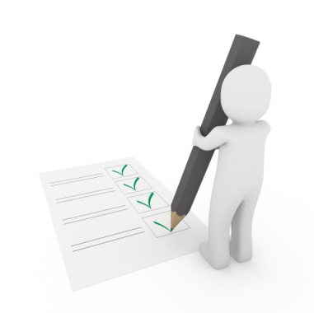
When a guest complains they want to be taken seriously and require an immediate response. The guest wants the situation resolved and someone to listen to them. By promptly addressing the complaint we have an opportunity to win the customer back again so we need to handle it effectively and efficiently.
See Section 2.7 for information about responding to complaints received via the telephone.
Messages for management, staff and guests can be received and disseminated from the telephonist area. Guest messages may be written or typed and added electronically to the guest room either as voicemail or written word. Messages may come from external associates or friends or family of the guest or messages may come from internal sources confirming a restaurant booking or a wakeup call confirmed.
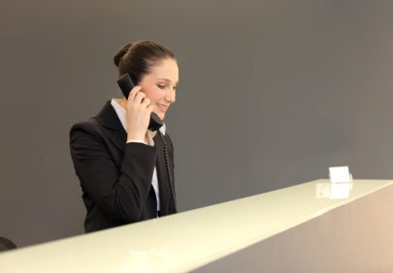
Contact with suppliers and return calls
Contact with Hotel or Resort to clarify orders or requests from suppliers may be made by telephone, suppliers may have to confirm orders or to change an order due the unavailability of a product. Suppliers may also contact a venue with information on new products or a range of items, and details of price and package size.
The Hotel or Resort may need to return calls to a variety of people due to an inability to take the call at an earlier time or people who have left a message either on voicemail or written form. Alternatively a call may be returned in reply to a message from guest or staff that was transferred by another department.

1.2 Identify the components of the telephone system

Introduction
The telephone system must be able to meet the Hotel’s needs so the Hotel or resort can function effectively, and also meet the guests’ needs. Guests have expectations of the communications system at the Hotel or Resort. An appropriate telephone system must be in place for this to happen, the telephone system must be capable of receiving and making multiple calls at one time, putting calls on hold and transferring calls.

The components of a Telephone system
A Landline telephone system is connected by solid wires or fibre optic cable, tangible and visible, from one location to another. The landline system includes multiple lines and multiple telephone numbers. The size or the system depends on the number of lines and numbers.

Mobile or cellular phones make and receive calls using radio link or wireless connection. These telephones can also support a wide range of other services such as text messaging or SMS, email and internet access, business applications and gaming and photography.
The mobile phones that incorporate general computing capabilities are called smart phones. These phones are used more frequently by guests and can be programmed to operate electronic door locks and in-house services such as room service orders. Staff increasingly use mobile phones to keep in contact with staff or department areas. Staff in housekeeping or Concierge may use mobiles to receive guest requests.
Paging systems for hotels help provide a best guest experience, keeping staff connected to offer the quality of service guests expect. A paging system offers discrete and immediate communication for staff. Paging systems and mobile phones allow staff to work in operational areas and still be able to respond quickly to requests and requirements. Modern pagers have capacity for text messaging and alerts and a storage capacity so messages can be referred to later.
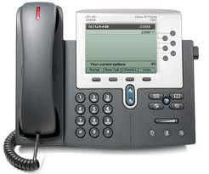
A switchboard is the piece of equipment that enables a Hotel or Resort to connect all the telephone lines and extensions used. All calls coming into the hotel or Resort will pass through the switchboard. The Switch board coordinates the telephone system and it allows the use of several lines and extensions at once, allowing other users to perform a range of other functions, place calls on hold, track all incoming calls and transfer calls.
Telephone handsets and headsets are constructed with a microphone to allow easy communication. The handset is the part of the telephone which the user holds to their ear. Handsets are often referred to as receivers. Cordless phones are more common. They use a radio transceiver and a base station and can be placed in a variety of locations for easier use.
VoIP Phone
Headsets fit over the head and enable hands free action which permits the operator to take notes or operate a computer while taking a telephone call. There are many varieties of headsets available on the market today:
- Wireless (cordless) Bluetooth and corded headsets
- Headsets with sound tube and multi-directional microphones for quiet environments
- Headsets with standard and ultra-noise cancelling microphones for noisy environments
- Headsets with mono and dual speakers
- Headsets with multiple wearing styles; over-the-head, over-the-ear and behind the head.
VoIP telephones use the internet to link and are rapidly increasing in usage, overtaking the traditional telephone network. The VoIP system enables notification of calls via email or text.
One of the major advantages of the current systems are caller identification facilities, including VIP caller ID. This includes some text, so if the guest calls room service the staff can see who called and which room number, enabling verification of the registered guest. The VoIP system links the telephone to the computer and this makes it easier and faster to check reservation details and any special notes.

1.3 Describe the functions and features available in the telephone system

Introduction
The telephone system has a number of other features and functions. The primary ones are the facility to place calls on hold or transfer calls, to record messages and text transmission. Other features include notification of missed calls and call diversion.

Features of the telephone system
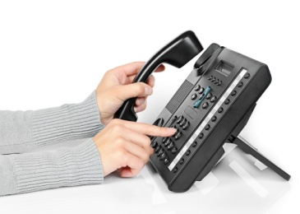
The telephone system must be able to meet the venue’s needs so that the venue can function effectively, and the guests’ expectations of the range of services. There are a variety of functions and features available in a telephone system.
Call waiting, sometimes called ‘catch phone’ in Japan, is the ability to suspend one conversation to answer the phone call of a third person without the first caller overhearing. There is usually a sound or flashing light indicating a new incoming call. When using an internet link call waiting function the technology accepts the call and displays caller ID information allowing the user to forward the call to another number, or to voicemail or to answer and to speak to the caller.
Call forwarding or call diversion is a feature which enables the user to redirect the call to a third party. The third party may be a mobile phone or to voicemail or other number. The other advantage is that a user can divert the phone to a new location if they have a meeting or conference in a different location.
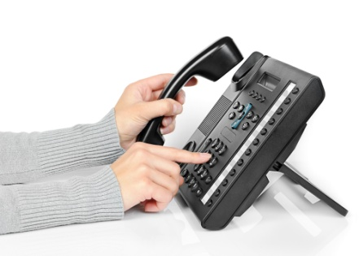
Caller Identification display or caller ID is a service which displays the caller’s details, from a pre-set data base, on to a screen on the telephone or for VoIP application on to a computer screen. Information can pass to the computer for the purpose of blocking or logging calls, and extending the data base. Caller ID can be used to limit prank calls or telemarketers.
Call blocking or call screening allows a receiver to block certain incoming calls. This feature when used with computer caller ID software can be more flexible, with options to block on partial numbers, such as just the area code, or a caller’s ID name.
Call-back occurs when the originator of a call is immediately called back in a second call as a response to a busy signal or missed call. Call back is also a method of redirecting long distance calls or international calls through a third country to reduce costs.
Call return is the process of returning all messages received or all missed calls. These calls may be stored electronically or from written messages kept.
Recorded message service can be a third party answering service which answers as your business and then forwards the information. The other form of recorded messages is voicemail which enables the caller to record a message and the recipient to act on the message. The most common messaging system is SMS text messaging. These messages can be stored and returned as voice or texts.

Executive busy override gives designated users the ability to break into an ongoing conversation. It may be to deliver an important message or a high priority phone call. This feature is important to a hotel or resort. The call interrupt feature enables reception to check a busy signal to ensure someone is on the line and the phone is in use - not just 'off the hook' or not in a receiving mode.
A call may be transferred to another telephone number or location and a transfer call can be put on hold and later recalled.
Placing calls on hold is required if a call cannot be answered immediately or the requested extension is busy. If a call is placed on hold the caller has to be asked if this is OK.

A multiple chat facility enables several callers to communicate at the same time. This facility is sometimes referred to as conference calls. These facilities are used by participants in conferences or meetings, enabling participants from distant locations to participate.
A conference call can also be conducted with computer software incorporating vision as well as sound with programs like SKYPE.
Integration of telephone facilities includes the interaction of telephone, telegraph, teleprinter, radio and microwave communications in conjunction with Internet use.
The integration of several services can lead to cheaper or more efficient use.
Work Projects
It is a requirement of this Unit that you complete Work Projects as advised by your Trainer. You must submit documentation, suitable evidence or other relevant proof of completion of the project to your Trainer by the date agreed to.
1.1 List protocols required when handling incoming calls from celebrities (VIPs) or highly placed public officials.
1.2 – 1.3 Use the internet to research the future use of cell phones in Hotels. Identify 3 major future trends involving Mobile phones.

Summary

Identify elements and facilities of the host enterprise telephone system
The telephone plays an important role in communication with a Hotel and within a Hotel or Resort. Incoming calls by landline and contact via mobile or cell phone including smart phones with internet linkage make up a high percentage of guest contact with a Hotel or Resort.
The telephone system must be able to meet the Hotel’s needs so the Hotel or resort can function effectively, and also meet the guests’ needs. Guests have expectations of the communications system at the Hotel or Resort. An appropriate telephone system must be in place for this to happen, the telephone system must be capable to receiving and making multiple calls at one time, putting calls on hold and transferring calls.
The telephone system has a number of features and functions. The primary ones are the facility to place calls on hold or transfer calls, to record messages and text transmission. Also notification of missed calls or call diversion.

Element 2:
Demonstrate appropriate telephone communication skills

2.1 Interpret the enterprise policies and procedures for telephone use in regard to incoming calls

Introduction
The use of the telephone is one of the most vital business tools in use today. More business is won or lost on the phone than by any other means. Every staff member should undergo formal training in correct telephone procedures.

Policies and procedures for telephone use
A hotel or resort will have a range of policies and procedures for telephone use some will be internal some are designed to conform to government regulation and may include:

Privacy
A hotel or resort will have a policy to protect the privacy and confidentiality of its guests. Guests’ messages and phone records are protected against fraudulent procedures. As identity theft is increasing an accommodation venue has to be scrupulous about how it handles personal and other information about guests.
Threatening calls
Response to threatening or suspicious calls requires the receiver to remain calm. The call should be taken seriously and the receiver should not hang up, as the origin of the call can be traced. It’s important to continue conversation to gain as much information as possible. A record of the call needs to be kept; either voice recorded or written. If a call is received as very threatening or suspicious then a supervisor or manager should be notified who would determine if there was a need to contact the authorities or police.
Greetings

Standard greetings are established to maintain image or service quality. Most standard greetings will include the requirement to answer the phone within three rings. Staff should answer calls courteously and identify the time of day, for example, ‘Good morning/afternoon’; the department or section, for example, ‘Bell Desk’; and then a name or job for example 'this is Evelyn at the reception desk' or 'this is the front desk duty manager' and pronounce words clearly, slowly, and with adequate volume to ensure the caller has time to process information.

Security
Authorisation or permission to use the system and nominated elements is normally monitored by management or supervisors. Staff will require special permission to operate the wakeup call system or access guest messages. VoIP systems linked to a computer system will have several levels of login and access.
Many hotels or resorts have created a "Privacy policy statement" relating to how and what they do with the personal information collected from guests. Such statements explain and outline the possibility that guests might have questions about how the hotel collects and uses the information that is provided by the guest. The statement verifies that, although the guest is asked at various times to provide information including but not limited to details, such as their name, email address or information about what they like and do not like. This information is only used to enhance services offered and to personalize products and services that the hotel thinks will interest the guest. Information collected about a guest while using the telephone remains within the hotel and is confidential.
Staff can often be tempted to pass on information about celebrities or prominent people to newspapers and magazines when these guests are staying at their hotel. Consequently staff need to be continuously reminded of their duty and responsibility to guests and the consequences, some of which could be legal action, if they break this privacy and confidentiality clause.

Training
Telephone system training is required to maintain the standards of the Hotel or resort. All systems require upgrading and even replacing and this will mean upgrade training for the staff that use the system and all its linked services. All staff who use the system should be involved in the training of the equipment’s functions and techniques and policies for answering incoming calls.
If staff are involved with a face to face activity with a guest and the telephone rings telephone etiquette dictates that staff need to excuse themselves and briefly answer the phone. It may be the caller is willing to wait and the call can be put on hold or a number taken and the call returned at a later time. Guests standing at the desk or making inquiries do not like to hear a phone ringing continuously and remaining unanswered.

2.2 Explain the importance of first impressions in relation to telephone answering and the reputation of the business

Introduction
The switchboard of a hotel or other hospitality business will have many calls coming in each day. As the switchboard is often the first contact that a guest or customer has with the establishment, it is very important staff are able to answer the telephone confidently and be able to direct the call to the appropriate person or department.

First Impressions

The voice that answers the telephone projects the image of the establishment and the tone and pitch convey the type and style of establishment. Many establishments nominate a 'script' to follow so all staff who use the telephone system offer the same standard greeting and project the image of the establishment. The first impression a guest is given is lasting, and will be difficult to alter if it’s an unfavourable one. The tone and language of the greeting will also influence the all important first impression and reflect on the establishment’s reputation.
Staff should answer with the establishment’s name and use a pleasant tone with the guest and use words and phrases that express the tone and standard of the venue.
For example
Staff; " Ling Hotel, Chen speaking, how can I direct your call?'
Or 'How can I assist you'

2.3 Differentiate between face-to-face and over-the-phone communications


Introduction
Guests who participate in face to face communication experience a range of communication techniques both verbal and non-verbal. When guests have a different first language to the hotel staff a non-verbal approach will help communication.

Face to face vs. telephone communication
Over the phone staff need to communicate the major part of any information with voice only so how and what is said is suddenly much more important. There is a need to think about voice tone, pace and volume, to project a professional image. On top of that things that would normally be shown visually, like friendliness or enthusiasm, also need to be communicated through the voice:
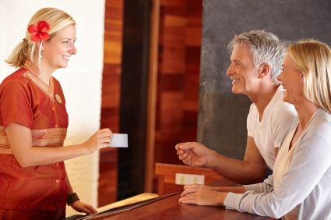
1) Communication face to face means that guests can get responses immediately without misunderstanding.
2) During face to face conversation, people can not only hear responses from others, but also see their expressions and body language and interpret how they are feeling. Non-verbal responses can indicate to staff the need to supply more information to clarify responses.
3) Face to face communication allows people to use eye contact. This helps get an understanding of the communication. Body language can offer a greater richness of information. If words don't match the non-verbal actions the listener has the impression of distorted information.
4) Body language will add to the communication in a face to face situation. Scientists show that more than seventy percent (70%) of people use body language in communication.
5) A face to face conversation will last longer as the more people talk together, the stronger and better relationship they have.
6) Telephone communication will require a greater use of questioning skills than face to face.
7) Telephone communication will require greater skill in listening and interpreting sounds as well as words.
If a guest asks for information about room rates and all the receiver hears from the caller is 'Ah' then staff could interpret this sound as indicating the price is too expensive.

2.4 Use appropriate telephone communication skills


Introduction
Telephone communication requires certain skills including the appropriate attitude, energy level, voice tone and volume. The ability to speak clearly and distinctly with no jargon and an ability to listen attentively is key.

Telephone communication skills
Conveying a helpful and positive attitude is reflected in the sound of a voice, using an upbeat tone of voice. It needs to be pitched at the right level. It shouldn’t be too high as it creates an irritating squeak, or too low so it sounds bored or sleepy. The pace of the speech can also demonstrate professionalism. Speech that is too fast is hard to understand. The guest may consider staff do not have time to serve them or are irritated with them. If staff speak too slowly the guest may think that staff are bored or unhelpful.
When using the telephone the staff should speak clearly and distinctly without the use of jargon or colloquial expressions. Staff should also avoid the use of industry jargon or acronyms. It’s important to use questions to check guests’ requests, the use of open questions to ensure staff get the best information. In adopting the use of positive language 'yes, we can arrange that for you'. 'Certainly we will attend to that for you' 'Yes' is the best response. Information should be given in a concise and polite manner.
All calls should be responded to in a professional manner, answered promptly and politely, assistance offered in a friendly manner and questions asked politely to establish the purpose of the call. All details should be repeated back to the caller in confirmation and any requests transferred to the appropriate department promptly. Details of guest requests should be recorded either electronically or written manually so an accurate record of information is kept. Staff answering guest requests should take the opportunity to promote in-house services and products.
Callers requiring to be transferred to a guest or hotel department should not be kept waiting. Calls may need to be screened. For example, staff should never transfer a call directly to a guest room without verifying the name of the guest the call is going to. Guests change rooms or may have do not disturb blocks on their in-room telephone.
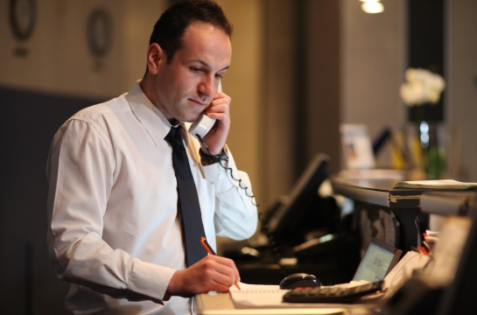
Telephone skills should include:
- Using the voice effectively and appropriately given the nature of the incoming call. If the caller is a guest wishing to make a reservation the voice should sound professional
- Applying effective listening and questioning skills to ascertain the caller’s need
- Demonstrating positive speaking skills; verbal communication should be clear and concise
- Responding professionally to all manner of incoming calls. Speak in a formal or business language
- Choosing appropriate tone, volume and language or version of the language to use in response to each incoming call
- Staff may have to ask questions to screen or block calls, as required.

2.5 Use appropriate telephone techniques

Introduction
Efficient and effective use of the telephone requires skill in using and knowledge of, the telephone system and the procedures and policies. All staff who use the telephone need to use appropriate telephone techniques.


Telephone techniques
Well developed telephone techniques will display an impression of professionalism and provide excellent service.
Clarify caller requirements
Use your questioning and listening skills to clarify what the caller has requested.
Repeat names, dates and times
Whenever guests give you details like their name make sure you spell it correctly. If you are not sure about the spelling then ask the guest to spell it. Read the letters back to the guest for clarification. Using the phonetic alphabet will help with an misunderstanding of letters being heard over the phone.
When you are given dates always read the dates back to the guest to confirm the details. In the case of time use a 24 hour clock to ensure there are no discrepancies between mornings, afternoons and evenings.
Phonetic alphabet
Phonetic Alphabet
A – Alpha  B – Bravo  C – Charlie  D – Delta  E – Echo  F – Foxtrot  G – Golf | H – Hotel  I – India  J – Juliet  K – Kilo  L – Lima  M – Mike  N – November | O – Oscar  P – Papa  Q – Quebec  R – Romeo  S – Sierra  T – Tango  U – Umbrella | V – Victor  W – Whisky  X – X-ray  Y – Yankee  Z – Zulu
- Use your voice effectively, including tone and volume
- Use your voice effectively. Some of us have more authoritative voices while others have quiet soft voices. Try to project a middle of the range voice
- The rate at which you speak can affect your voice – try not to be too slow or too fast
- Speak directly into the mouthpiece. Adjust the headset to make sure it is suitable
- If your pitch is too monotone or too high it can be undesirable
- Keep your voice at a reasonable volume – louder doesn’t mean clearer
- Your tone should vary along with inflections – but try to keep it sounding normal
- Sit up straight and be comfortable in your working environment
- Your voice should reflect a professional image
- You should have a smile in your voice.

2.6 Describe acceptable telephone etiquette

Introduction
Handle calls in accordance with house policies and procedures. For example, calls are answered quickly and courteously and directed to the appropriate department without delay and redirected, if necessary. Messages containing all the necessary information are passed on to guests without delay (placing message slip under door, activating message waiting system etc.)

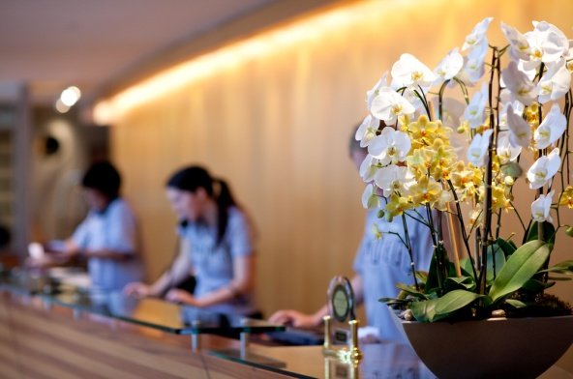
Telephone Etiquette
- Answer the call within the second or third ring
- Always speak clearly and slowly with courtesy, civility and respect
- Avoid extreme volumes
- Avoid jargon or hotel terminology
- Speak with a smile on your face
- Use an appropriate opening phrase and listen to the response. Reduction of background noise can make hearing more efficient

- If there is caller ID on the telephone system then staff should use the guest's name
- Repeat the details back to the guest
- Always use the caller's name if known, otherwise, sir or madam
- Ask how something is spelt if you can't understand
- Transfer calls promptly
- Never eat, drink or smoke while on the phone
- Use a suitable closing phrase – thank the caller for calling
- Always allow the caller to hang up first before terminating the call.
Staff should demonstrate the ability to correctly operate the telephone equipment and system to prevent caller frustration and complaint:
- Always ask the caller if they would like to be placed on hold before placing them on hold
- Apologising for delays, including never leaving a caller on hold for longer than 30 seconds without some form of contact
- If the call is to be redirected advise the caller of the name of the person to whom their call is being directed or transferred
- Staff should advise the caller of the conclusion of the call and the actions that will be taken.

2.7 Identify common caller complaints about telephoning a business

Introduction
The most common method of contact with a hotel or resort is the telephone system, either landline or digital. Sometimes guests have cause to complain or express dissatisfaction with the system or process. Staff from several departments can be the recipients of guest complaint and frustration if the telephone system is malfunctioning.

Common caller complaints
- The telephone rings too long before being answered. If the guest is waiting to have a call answered they can become frustrated and angry. Some telephones have capacity to record how long a phone rings before it's attended to. A guest speaking face to face with staff will find it distracting if a phone rings and rings without being answered
- Being placed on hold for too long, Guests should always be asked if they want to be on hold or for a message to be taken. If a guest is on hold then staff should check back frequently

- Inability to get through, such as the line or number is always busy. Again if the guest is waiting to have a call answered they can become frustrated and angry, Some venues have electronic messaging or voicemail to avoid this
- If a guest has complained and the receptionist becomes defensive or abusive. The guest or caller may ask for the receptionist’s name so the guest can take their complaint further
- Difficulty can arise if reception or the switchboard fails to determine where the call should be directed. This could mean there has been a failure to update contact information
- One of the important points of communication is to listen. Failure to listen to guest's requests and questions can lead to misunderstanding and disgruntled guests
- All systems can experience system failure. Often the failure is outside the control of management. Occasionally incompetence with the system; for example, the caller is disconnected when being transferred. This is the cause of guest dissatisfaction
- Lack of professionalism, including failure to place call on hold before talking to colleagues, giving an inappropriate greeting, lack of knowledge about the establishment and its staff. the use of an Improper tone of voice used by receptionist are all situations which can be cause for caller complaint.

Responding to complaints received on the telephone
When responding to complaints received via the telephone staff need to:
- Determine what the complaint is: it could be something that can be resolved easily. Get the right person to call them back and respond to the complaint.
- Acknowledge the issue: express concern and apologize on behalf of the establishment. Try not to blame anyone in particular.

- Let them know what action will be taken: the person you have called might want something like a sincere apology, a complimentary item or a refund. You might be able to do this immediately or will have to call the guest back.
- Make sure you follow up with what you said you would do: passing the complaint on to a supervisor or sending something in the mail.

Work Projects
It is a requirement of this Unit that you complete Work Projects as advised by your Trainer. You must submit documentation, suitable evidence or other relevant proof of completion of the project to your Trainer by the date agreed to.
2.1 Research your local telephone provider’s policies and list the policies and procedures about privacy of information.
2.2 Contact 3 establishments by phone to make enquiries or ask a question. Comment on your first impression.
2.3 Visit one of the establishments in Work Project 2.2. or check the web site. Was your first impression correct? Would you change your impression after viewing the establishment?
2.4 – 2.6 Using your conversation in Work Project 2.2 discuss the skill level you experienced. List the telephone techniques used and comment on the use of telephone etiquette.
2.7 Research the risk management strategies for a telephone system in the event of power failure.

Summary

Demonstrate appropriate telephone communication skills
The use of the telephone is one of the most vital business tools in use today. More business is won or lost on the phone than by any other means. Every staff member should undergo formal training in correct telephone procedures
The switchboard of a hotel or other hospitality business will have many calls coming in each day. As the switchboard is often the first contact that a guest or customer has with the establishment, it is very important staff are able to answer the telephone confidently and be able to direct the call to the appropriate person or department
Guests who participate in face to face communication experience a range of communication techniques both verbal and non-verbal. When guests have a different first language to the hotel staff then non-verbal communication may be more effective
Telephone communication requires certain skills, including the appropriate attitude, energy level, voice tone and volume. This includes the ability to speak clearly and distinctly with no jargon and an ability to listen attentively
Efficient and effective use of the telephone requires skill in the use and knowledge of the telephone system and the procedures and policies. All staff who use the telephone need to use appropriate telephone techniques
Handle calls in accordance with house policies and procedures. For example, calls are answered quickly and courteously, are directed to the appropriate department without delay and redirected if necessary. Messages containing all the necessary information are passed on to guests without delay (placing message slip under door, activating message waiting system etc.) Staff should demonstrate the ability to correctly operate the telephone equipment and system to prevent caller frustration and complaint
The most common method of contact with a hotel or resort is the telephone system, either landline or digital. Sometimes guests have cause to complain or express dissatisfaction with the system or process. Staff from several departments can be the recipients of guest complaints and frustration if the telephone system is malfunctioning.

Element 3:
Receive incoming calls

3.1 Prepare to receive incoming calls

Introduction

As with any work station telephonists or receptionists need to organise the work area, ensuring the system is functioning and all necessary stationery is available including message pads and pens and paper for printers. At the commencement of a shift staff should log on if the system is computer-based, and check any memos or updates of in-house information, including obtaining or preparing an internal telephone list, and an up-to-date in- house guest list of registered guests. A list of internal extension numbers and frequently used numbers should be available. For reference a telephone system user manual is a requirement. This is normally provided with any introductory training.

Preparing to take calls
Reception or telephone staff should be doing all the necessary things in order to efficiently and confidently receive and make telephone calls:

- Start with a smile on your face – this will reflect in your voice when you are talking, improving the tone and pitch
- Have paper and pen ready to record information
- Have a comprehensive list of in-house extensions by the phone. This may be electronic or written, or may be the in-house guest report as produced by the night auditor
- Have a list of frequently called numbers such as taxis, theatres, restaurants, tourist tour operators or other external services. There should also be a list of emergency numbers such as medical professionals, doctors, dentists, physiotherapy etc
- Know where and how to direct each enquiry. A good knowledge of all departments and their areas of responsibility will ensure prompt response to all enquiries
- Sit upright and adjust the chair and equipment to best suit the person's stature
- Have a sound knowledge of all operator connected calls, and directory assistance procedures. The telephonist may need to prioritise calls according to property guidelines and activate call waiting and other automatic systems such as message waiting system or the wakeup call system. The telephonist may also have to activate the voice mail system
- When operating the telephone system staff must ensure there are no outside distractions.

3.2 Answer calls promptly in accordance with house standards

Introduction
Phone answering skills are critical in maintaining the good image and reputation of a hotel or resort. The phone is the primary point of contact with guests and customers. Also the manner in which staff answer the establishments phone will form your customer's first impression of your business.

House standards
All staff who use the telephone to accept incoming calls should maintain the same standard etiquette and skills.
When answering calls staff should ensure all calls are answered before the house ring limit is reached; usually by the third ring.
Using an enterprise standard greeting is a statement of who you are and what your establishment’s values are. A short and abrupt greeting will send a negative message to your callers. A long and drawn-out greeting will frustrate them. A properly composed greeting can leave your callers with a positive image.

Staff: Good morning, Singapore Grand hotel, this is Sally. How may I help you?
Caller: Can you put me through to Room 2014 please
Staff: Certainly, may I have the guest’s name please?
Caller: It is Mr. Bolton-Smyth
Staff: Thank you, I will put you through now
Identifying self or position and the hotel or resort, greet the caller and offer assistance or ask questions to ascertain the purpose of the incoming call.
Points to note:
- Focus and concentrate on the call, especially listening carefully to the caller’s voice
- Take notes and details of any request.
- Identify whether the caller is calling long-distance or internationally
- Identify if the caller is a designated VIP caller, a return guest or a corporate guest whose company has a contract with the hotel or resort.
By asking what the call is about, staff are able to determine if the correct person is being asked for and if it is appropriate to put a call through. Screening of calls in this way prevents prank calls and unwelcome invasion of the privacy of guests.
Placing existing calls on hold to answer an incoming call, is the feature enabling the telephonist to suspend one conversation to answer the phone call of a third person without the first caller overhearing. There is usually a sound or flashing light indicating a new incoming call. When using an internet link ‘call waiting’ the technology accepts the call and displays caller ID information allowing the user to forward the call to another number, or to voicemail or to answer and to speak to the caller.

3.3 Identify long-distance or international calls

Introduction
Long distance calls or IDD, International Direct Dial service refers to long distance calls between countries with or without operator intervention. Also known as international standard dialling (ISD). All countries have their own identity number.

International calls
A free call line, also referred to as a ‘toll free line’, is a telephone line whereby the venue pays for the cost of the incoming call. It is usually only available for incoming long distance calls, usually for the reservations department.
With caller ID the telephonist will see the "Country Code" for the country where the call originated, then the city code and the local number (see below). Usually the person calling will have pre-organised the call to ensure the recipient is available.
The International way of dialling works like this:
(The number below is for the British Museum in London, UK)
+44 (0) 20 7323 8000
Country
Code
City
Code
Phone
Number
Country Code: +44 = England
Local Code: (0) = Do not dial this unless you are in England!
City Code: 20 = London
Local Number: 7323 8000
The list of country codes should be placed in an easy place and accessible to all of the staff.
Calls from other countries will need to be coordinated with time zone information. Charges for international calls vary according to time zone and distance.
When answering incoming calls from international locations, staff may need to have language skills or access to interpreters or software that would perform translation. International calls may be connected by a telephone operator or satellite connection and fees will vary according to the country and duration of the call. Another influencing factor is the method of connection. A satellite call is more expensive than wireless connection.
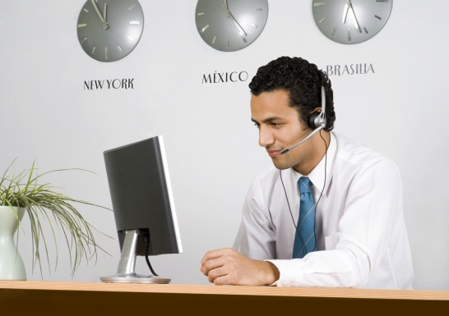

3.4 Establish purpose of incoming calls

Introduction
When receiving incoming calls it’s important to determine the purpose of the call. So it can be directed to the appropriate staff or department In a large hotel or resort the telephone operator may answer calls on behalf of several different departments and then transmit the information to appropriate staff by pager or text.


Determine purpose of call
- Following the initial greeting it's important to clarify the caller’s need and, if required, transfer the call to another department or section, for example Food and beverage for restaurant bookings or Sales and marketing for function or conference bookings and Housekeeping for a room feature request
- Making an enquiry - clarifying information with questions to gain more information to enable the checking of what is available
- Seeking information from the hotel’s database or directory. The telephonist may use the internet for research also; seeking extra information from expert sources such as a historical society or animal expert etc.
- Selling and marketing promotions to meet the needs of a particular market segment.
By repeating information supplied by the caller, the telephonist can clarify information, including paraphrasing to confirm understanding of the callers request.

3.5 Respond to caller requests, where appropriate

Introduction
A hotel or resort offers a wide range of services including Functions for conferences or special occasions such as weddings. Potential guests may want information about on-site businesses such as the Spa and wellness centre or the Marina. Reservations for restaurants or accommodation may be received. These requests will require knowledge of product and availability.


Caller Requests
In the Hospitality Industry, remember that the guest is the reason you work, not an interruption to it. If there were no guests, you would not have a job. You are in a service industry and your job is to give good service. When a guest asks questions, you must never think of it as an inconvenience. React promptly, give the guest your full attention and show genuine interest in their questions.
If you know the answer:
- Tell the guest and ask if there is anything else you can help them with
- Finish the conversation with a pleasant greeting e.g. ‘I hope you enjoy your stay’.
If you don’t know the answer:
- Never make it up or say, ‘I don’t know’ or ‘That’s not my department’. You should apologise where an immediate, correct response cannot be given
- Offer to find out and get back to the guest with the answer. This may involve putting the guest on hold or taking details and returning the call
- Do not keep the guest waiting while you try to find the answer. Offer to deliver the information or call back or transfer the call to a guest services attendant or another department who can best answer the question
- Make sure you follow up and get back to the guest quickly.

3.6 Take messages from callers

Introduction
When taking a message for a guest or another department it is important to be accurate and to process the message as quickly as is practical. If a guest does not receive messages in full, it may not only cause the guest embarrassment but possibly a financial loss. For example, a business client may leave a vital business message. If messages are not delivered promptly guests may be inconvenienced and the establishment may receive a strong complaint. The guest may never return to your establishment in these circumstances.

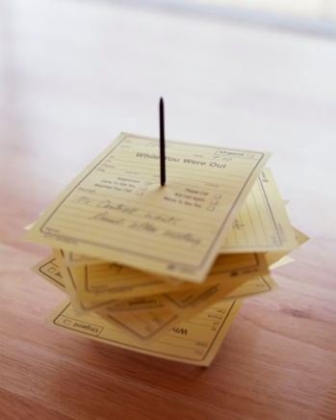
Taking a message
When a person calls to leave a message for a guest the first task is for you to check the guest is a registered guest. Remember, however that staff should never give out guest room numbers without the registered guest’s permission.
Listen carefully when taking a message. The message may be recorded verbally on voicemail, written or electronically transmitted via the PMS system and visible on the TV or Intranet. A caller who is leaving a message should be given a choice of method.
At the commencement of the shift a telephonist needs to be prepared with a pen, note pad, message pad or template, a calendar, lists of frequently called numbers and a telephone directory all within easy reach.
To take messages accurately make sure that you record:
- Who the message is for; the full name remembering that you might have 10 guests with the name Ng or Lee staying in the hotel
- Who left the message; repeat the name back and make sure that you have the correct spelling. Record any details of the Company and the Caller’s City (this is required to estimate time for the return call to occur)
- The number and any extension of the person leaving the message. Check and repeat this back to the caller so that you do not give your guest the wrong number
- An accurate message should be taken. Repeat the message back to confirm this with the caller. Confirm the importance and urgency and any action requested or promised
- Lastly record the date and time of the call, including the action and follow-up. Also include the name of the person who recorded the message. If the message has been entered into an electronic system or PMS, then it will automatically be dated, time stamped and carry the ID of the staff member who entered the data.

3.7 Relay messages and follow-up as necessary

Introduction
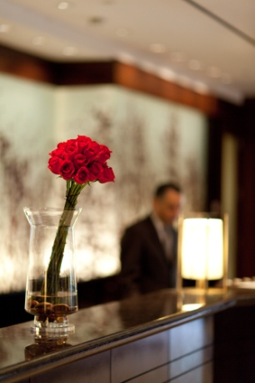
All messages received and recorded need to be distributed to their recipients. It is essential that messages are timely and accurately distributed. Porter duties usually include taking messages, packages or mail for in-house guests in liaison with reception staff, receiving and distributing guest mail, messages, emails and faxes. A message may be left for an expected guest and notification can be attached electronically to the reservation information.

Distribution of Messages
Messages in hard copy can be left under guests’ doors or a message notification can be activated, a light on the telephone or electronic notification on the TV or guest’s mobile phone. Text messages can be transmitted instantly.
Message notification may occur via the use of an internal paging system, especially if the message is urgent or one that is for a group of guests.
Messages may be left in a pigeon-hole or message book. Having been notified that a message is waiting for them, a guest may call at the front desk or reception to collect a message or to have hotel staff read it to them.
Messages left for incoming guests may be delivered verbally at check-in or printed and handed to the arriving guest.

If a message has been left with an instruction to send an answer or notify the sender of the progress or receipt of the message this action needs to be completed. A message may carry a facility to confirm delivery.

3.8 Facilitate conference calls
A conference call is a telephone call in which the calling party wishes to have more than one called party listen in to the audio portion of the call. The conference calls may be designed to allow the called party to participate during the call, or the call may be set up so that the called party merely listens into the call and cannot speak while it can also be set up to view the other caller. This is sometimes called Tele-Conference.
Conference calls can be designed so that the calling party calls the other participants and adds them to the call. However, participants are usually able to call into the conference call themselves by dialling a telephone number that connects to a “conference bridge” (a specialized type of equipment that links telephone lines).
Companies commonly use a specialized service provider who maintains the conference bridge, or who provides the phone numbers and PIN codes that participants dial to access the meeting or conference call.
The more limited ,three-way calling’ is available (usually at an extra charge) on home or office phone lines. For a three-way call, the first called party is dialled. Then a button (or recall button) is pressed and the other called party's phone number is dialled. While it is ringing, flash/recall is pressed again to connect the three people together. This option allows callers to add a second outgoing call to an already connected call.

3.9 Deal with suspicious or threatening calls

Introduction
Threatening and suspicious calls vary in type, it could be a caller who is abusive or drunk, it could be a bomb threat or threat of violence to guests, staff or property. A telephonist should notify a supervisor or departmental manager if there is a difficult situation or threat. There may be an alert system to activate which notifies authorities or a recording device to activate.


Threatening and suspicious calls
Whatever the threat or suspicious behaviour there are certain steps to follow.
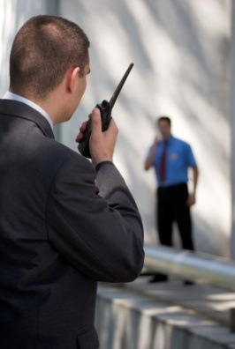
It is important to remain calm. Do not hang up as this can enable the authorities to trace the call. By capturing as much detail as possible about the call, caller and nature of the threat, the caller should be treated with respect and not abused. Staff should not laugh or treat the threat lightly. It’s important not to be angry or upset as this could cause the caller to become agitated and hang up or escalate the situation. But it is also important to confirm the call is genuine and not a prank or joke. Despite the cause or reason a record should be kept of the conversation.
If it’s a bomb threat then try to get as much information as possible, who the group or individual is who is making the threat, why and how will they will carry out their threats. There is a need to establish who specifically the threat is against and why or when it will occur or if there is any action the telephonist can take that will solve the problem or difficulty.
The venue’s policies and procedures have to be followed and management and other staff notified of the situation. It may be that staff need to Initiate an evacuation or implement the Emergency Management Plan (EMP) and also notify relevant authorities. If there is a serious threat management will call departments and room numbers to facilitate the warning of people in accordance with the Emergency Management Plan.
All threats and suspicious behaviour should be taken seriously and immediately contact a supervisor as to what is occurring.

3.10 Manage difficult callers

Introduction
Occasionally staff may find themselves having to answer the phone to a difficult caller. This will require tact, quick action or initiative. The Telephonist must determine the cause of the difficulty and establish if the caller has a complaint, if they have difficulty communicating or are they drunk or incapacitated. Perhaps the guest has just had a bad experience and is venting to the person who answered the phone.


Difficult callers
Communication
Callers who are from a different culture may have language differences. The common language or business language may be the guests 3rd or 4th and fluency may be causing the problem; the guest cannot make themselves understood. This is also true of a caller who has a disability or has been a victim of an accident or illness which has affected their speech.
If a caller has trouble being understood this can lead to frustration and anger which can explain the 'difficult customer'.
To avoid this situation the telephonist needs a knowledge of language and access to translators or software to assist.
Intoxication
A caller who is drunk may become very difficult or aggressive on the phone, words are slurred and not easy to understand and alcohol can alter the caller’s ability to think logically and small acts are seen by the caller as cause for complaint. The inebriated guest can also become agitated and may threaten violence. This type of caller should be handled as a threatening call.
Bad service
A guest may use the telephone to make a complaint about a service or feature of the hotel and the outcome has not been satisfactorily resolved. If a guest feels that their complaints have not been taken seriously, or the complaint made light of or even laughed at by staff, the guest may pursue it angrily and become a difficult caller.
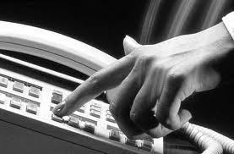
Rude callers
Some callers, due to travel tiredness or jet lag, or bad service suffered elsewhere may be abusive or aggressive if service or information is not quick enough or their perception is of bad service when circumstances work against them. The guest who arrives after a long flight, has lost luggage or experienced poor taxi travel may arrive at the hotel to find at 0600 hours the hotel has no vacant rooms and may prove difficult to the front desk staff.
When answering a difficult call the telephonist must first listen, then apologise.
Come to a conclusion explaining what action can be taken. Identify how the complaint will be dealt with and always follow up.
While capturing as much detail as possible about the caller the caller should still be treated with respect. However it is also important to confirm the call is genuine and not a prank or hoax. Despite the cause or reason a record should be kept of the conversation. A difficult guest may simply be misunderstood, but for those who are angry or upset and not responding positively, remember to be tactful, keep cool, sympathise and try to give assistance but always call or notify management.

3.11 Prepare voicemail messages and background music

Introduction
Voicemail is a computer-based system that will answer the caller and deliver voice information about organizations, products and services, using an ordinary telephone. The term is also used more broadly to denote any system of conveying a stored voice messages. Voicemail systems are designed to convey a caller's recorded audio message to a recipient.
Most telephone systems have the ability to play an advertising message or music when a call is placed on hold or before it answers. Calls are placed on hold because there is a bank up of calls and the operator is busy.
Sometimes calls are put on hold manually. For instance, when you need to get some information for the guest you will inform them that they are going to be put on hold while you collect this information or speak to a supervisor. In this circumstance music or promotional messages can be used rather than the caller listening to nothing.

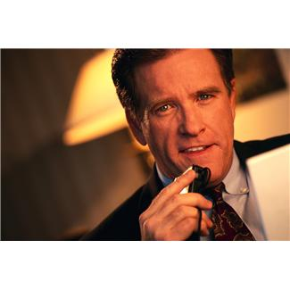
Preparing voicemail messages
Establishments are increasingly using recorded messages and instruction to automatically answer a telephone call, especially after hours. Determine the content of the message. It should be brief and give information about operational times and confirm the name of the establishment. The name of the city is often included so time zones can be identified.
The hotel or resort’s telephone system will provide callers with a new level of professionalism and confidence with music on-hold as they wait to be transferred to a live representative. The choice of music needs to be representative of the image of the establishment. It may be culturally-based, instrumental or current popular music. There will be a range of available from specialist music formatting companies or it can be accessed on the internet or simply purchased as a CD selection. Specialist music preparation will include a continuous play function.
Any recorded message must also confirm the reason for the diversion. The Hotel or resort may have a recorded message for callers who have been placed on hold. This may include information and advertising for services and features and any special promotions.
By recording messages for callers who are being transferred an establishment may have specific information about the section the caller is to be transferred to, such as features or services or times of operations. When recording messages for individuals where there is no answer on the extension you need to include information as to alternate information or hours of operation.
It’s important when recording after hours messages that clear and brief information is conveyed indicating when and how the caller can leave a message or contact the establishment.
Recording call waiting messages may include an apology and information on how to access an extension or identifying how the waiting process is structured.

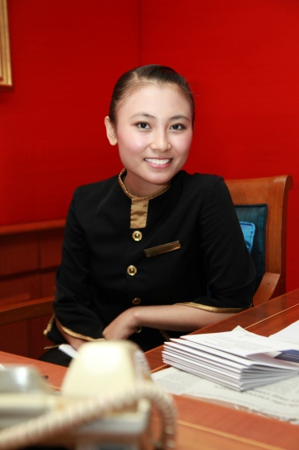
Work Projects
It is a requirement of this Unit that you complete Work Projects as advised by your Trainer. You must submit documentation, suitable evidence or other relevant proof of completion of the project to your Trainer by the date agreed to.
3.1 Research and summarize the equipment you would need to check in preparation for receiving incoming calls.
3.2. Call or contact two (2) major Hotels or Resorts and compare the enterprise standard greeting and information given.
3.3. List the international codes for 6 countries identified as common sources or tourists to your local area. Include information about which time zone they belong to.
3.4. Research the purpose of incoming calls and list 5 that would be common to a hotel or resort in your area.
3.5 Select three (3) hotel internet sites from your region and list likely caller requests.
3.6 – 3.7 Design a message template for English and one other language. Create a departmental distribution list for internal messages.
3.8 Research two (2) brands of telephone system with conference call facility and compare the features.
3.9 – 3.10 Research the internet for protocols for dealing with difficult callers and create a reference list. Using this information create a definition of a difficult caller
3.11 Research brands of voicemail equipment and compare the features of at least three (3).

Summary

Receive incoming calls
At the commencement of a shift staff should log on if the system is computer-based, and check any memos or updates of in-house information, including obtaining or preparing an internal telephone list, and an up-to-date in-house guest list of registered guests
Phone answering skills are critical in maintaining a good image and reputation of a hotel or resort. The phone is the primary point of contact with guests and customers. Also the manner in which staff answer the establishment’s phone will form your customer's first impression of your business
Long distance calls or IDD (International Direct Dial) service refers to long distance calls between countries with or without operator intervention. Also known as international standard dialling (ISD). All countries have their own identity number
When receiving incoming calls it’s important to determine the purpose of the call so it can be directed to the appropriate staff or department. In a large hotel or resort the telephone operator may answer calls on behalf of several different departments and then transmit the information to appropriate staff by pager or text
.A Hotel or Resort offers a wide range of services including Functions for conferences or special occasions such as weddings. Potential guests may want information about onsite businesses such as the Spa and wellness centre or the Marina. Reservations for restaurants or accommodation may be received. These requests will require knowledge of product and availability
When a person calls to leave a message for a guest the first task is for you to check that the guest is a registered guest, Remember staff should never give out guest room numbers without the registered guest’s permission. Listen carefully when taking a message, the message may be recorded verbally on voicemail, written or electronically transmitted via the PMS system and visible on the TV or Intranet
All Messages received and recorded need to be distributed to their recipients. It is essential that the distribution of messages is timely and accurate. Porter duties usually include taking messages, packages or mail for in-house guests in liaison with reception staff, receiving and distributing guest mail, messages, emails and faxes. A message may be left for an expected guest and notification can be attached electronically to the reservation information
A conference call is a telephone call in which the calling party wishes to have more than one called party listen in to the audio portion of the call. Conference calls may be designed to allow the called party to participate during the call, or the call may be set up so that the called party merely listens into the call and cannot speak while it can also be set up to view the other caller
Threatening and suspicious calls vary in type. It could be a caller who is abusive or drunk, it could be a bomb threat or threat of violence to guests, staff or property. A telephonist should notify a supervisor or departmental manager if there is a difficult situation or threat. There may be an alert system to activate which notifies authorities or a recording device to activate
Occasionally staff may find themselves having to answer the phone to a difficult caller. This will require tact, quick action or initiative. The Telephonist must determine the cause of the difficulty – does the caller have a complaint?, do they have difficulty communicating? or are they drunk or incapacitated?, Maybe the guest has just had a bad experience and is venting to the person who answered the phone
Voicemail is a computer based system that will answer the caller and deliver voice information about organisations, products and services, using an ordinary telephone. The term is also used more broadly to denote any system of conveying a stored voice message. Voicemail systems are designed to convey a caller's recorded audio message to a recipient.

Element 4:
Re-direct incoming calls

4.1 Transfer calls as appropriate

Introduction
The skill of transferring a call does not only depend upon the understanding of the establishment's telephone equipment but also requires a courteous and professional manner.
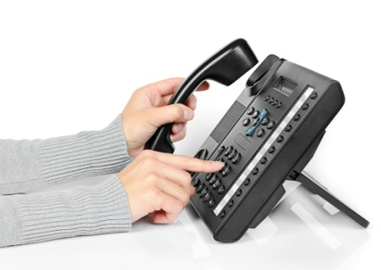
In most cases, when a person calls an establishment they will expect to be transferred. However, this transfer must work efficiently for the caller. Do not send them to the wrong department, do not cut them off in the process, do not allow the guest or caller to repeat themselves to everyone that answers the phone and make sure you know how to correctly transfer a call.

Transfer Calls
The procedure to transfer a call is:
- Answer the incoming call according to establishment procedures, and find out who the call is for
- Thank the caller for their call and let the caller know you are going to transfer them. Give them a chance to object if they want and this will also let them know where they are being transferred to
- If the caller doesn't want to be transferred you need to take a message.
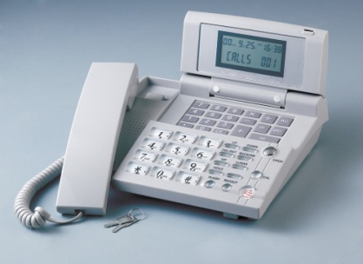
When the phone is answered identify yourself, let them know you are transferring a call and tell the person what the caller wants. This will prevent the guest having to repeat themselves. If you transfer a call and do not wait for someone to pick up the call at the other end most telephone systems will allow for transfer recall. That is, the call will bounce back to you if it is not answered by a person or an answering/voicemail machine. If this is the case then you must let the caller know that the other area is unavailable and give them the option of leaving a message or calling back.
Likewise if the line is engaged or after a programmed number of rings the call will transfer back to the operator again advising the guest of their options.

4.2 Place calls on hold as appropriate

Introduction
Placing calls on hold is required if a call cannot be answered immediately. If a call is placed on hold the caller has to give permission. A caller placed on hold without being informed may feel confused and disappointed with the service standard. They may also feel angry and that they are not important to the venue.

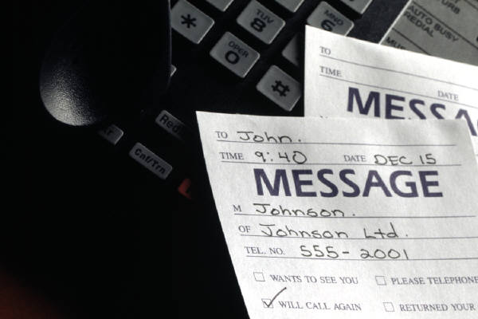
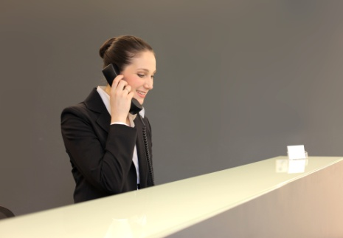
Placing a call on Hold
A call may need to be placed on hold because the extension may be busy or there are several other calls to attend to at the same time. If a caller indicates that they do not want to be put on hold and ask to have the call dealt with immediately, then you may have to take information and return the call at a later time.
Most telephone systems have the ability to play an advertising message or music when a call is placed on hold or before it answers.
Sometimes calls are put on hold manually. For instance, when you need to get some information for the guest, you will inform them that they are going to be put on hold while you collect this information or speak to a supervisor. It is good practice to advise the guest what you are doing.
If a caller is on hold don’t forget to keep coming back to them to let them know what is happening. For instance, the line they are waiting for may be still busy – do they want to call back or leave a message?

Work Projects
It is a requirement of this Unit that you complete Work Projects as advised by your Trainer. You must submit documentation, suitable evidence or other relevant proof of completion of the project to your Trainer by the date agreed to.
4.1 – 4.2 Use the internet to research telephone systems with Hold and Transfer features. Compare two (2) brands and report which would be the most appropriate for a hotel or resort.

Summary

Re-direct incoming calls
- In most cases, when a person calls an establishment they will expect to be transferred. However, this transfer must work efficiently for the caller. Do not send them to the wrong department, do not cut them off in the process, do not allow the guest or caller to repeat themselves to everyone that answers the phone and make sure you know how to correctly transfer a call
- Placing calls on hold is required if a call cannot be answered immediately. If a call is placed on hold the caller has to give permission. A caller placed on hold without being informed may feel confused and disappointed with the service standard. They may also feel angry and that they are not important to the venue.

Presentation of written work

1. Introduction
It is important for students to present carefully prepared written work. Written presentation in industry must be professional in appearance and accurate in content. If students develop good writing skills whilst studying, they are able to easily transfer those skills to the workplace.

2. Style

Students should write in a style that is simple and concise. Short sentences and paragraphs are easier to read and understand. It helps to write a plan and at least one draft of the written work so that the final product will be well organized. The points presented will then follow a logical sequence and be relevant. Students should frequently refer to the question asked, to keep ‘on track’. Teachers recognize and are critical of work that does not answer the question, or is ‘padded’ with irrelevant material. In summary, remember to:
- Plan ahead
- Be clear and concise
- Answer the question
- Proofread the final draft.

3. Presenting Written Work
Types of written work
Students may be asked to write:
- Short and long reports
- Essays
- Records of interviews
- Questionnaires
- Business letters
- Resumes.
Format
All written work should be presented on A4 paper, single-sided with a left-hand margin. If work is word-processed, one-and-a-half or double spacing should be used. Handwritten work must be legible and should also be well spaced to allow for ease of reading. New paragraphs should not be indented but should be separated by a space. Pages must be numbered. If headings are also to be numbered, students should use a logical and sequential system of numbering.
Cover Sheet
All written work should be submitted with a cover sheet stapled to the front that contains:
- The student’s name and student number
- The name of the class/unit
- The due date of the work
- The title of the work
- The teacher’s name
- A signed declaration that the work does not involve plagiarism.
Keeping a Copy
Students must keep a copy of the written work in case it is lost. This rarely happens but it can be disastrous if a copy has not been kept.
Inclusive language
This means language that includes every section of the population. For instance, if a student were to write ‘A nurse is responsible for the patients in her care at all times’ it would be implying that all nurses are female and would be excluding male nurses.
Examples of appropriate language are shown on the right:
Mankind | Humankind
Barman/maid | Bar attendant
Host/hostess | Host
Waiter/waitress | Waiter or waiting staff

Recommended reading
User manuals and Instruction booklets for the telephone systems being used in the
training institution

Facchinetti, A., 2003, Responding to the call, Tertiary press, Croydon, Victoria, Australia.

Finn, C., 2007, Manners on the telephone, Picture Window Books, Minneapolis, Minn.

Hajncl, L., 2002, [kit], What's my line?: telephone tasks and activities for ESL, Adult
Migrant Education Services, Melbourne.

Hickman, A., 2008, Communicate on the telephone: SITXCOM004A, William Angliss Institute, Melbourne, Australia.

Hughes, J., 2006, Telephone English, Macmillan, Oxford. (includes phrase bank, audio
CD and role plays)

Jurek, L., 2008, Terrific telephone techniques, 3rd edn., Terrific Trading, West Leederville,
W.A.

Lowe, S., 2004, [kit], Telephoning, Delta, Addlestone, Surrey.

Marks, G., 2008, Big hearted telephone customer service: 6 practical steps for great
telephone customer service, Sound Training Solutions Pty. Ltd., Greystanes, N.S.W.

Maxwell, D., 2006, Phone skills for the Information age, McGraw-Hill/Irwin, New York.

Trainee evaluation sheet

Receive and place in-coming phone calls
The following statements are about the competency you have just completed.
Please tick the appropriate box | Agree | Don’t Know | Do Not Agree | Does Not Apply
There was too much in this competency to cover without rushing.
Most of the competency seemed relevant to me.
The competency was at the right level for me.
I got enough help from my trainer.
The amount of activities was sufficient.
The competency allowed me to use my own initiative.
My training was well-organized.
My trainer had time to answer my questions.
I understood how I was going to be assessed.
I was given enough time to practice.
My trainer feedback was useful.
Enough equipment was available and it worked well.
The activities were too hard for me.

The best things about this unit were:

The worst things about this unit were:

The things you should change in this unit are:

Trainee self-assessment checklist
As an indicator to your Trainer/Assessor of your readiness for assessment in this unit please complete the following and hand to your Trainer/Assessor.

Receive and place in-coming phone calls
 |  | Yes | No*
Element 1: Identify elements and facilities of the host enterprise telephone system
1.1 | Identify the types of incoming calls that may be received and their importance to the business
1.2 | Identify the components of the telephone system
1.3 | Describe the functions and features available in the telephone system
Element 2: Demonstrate appropriate telephone communication skills
2.1 | Interpret the enterprise policies and procedures for telephone use in regard to incoming calls
2.2 | Explain the importance of first impressions in relation to telephone answering and the reputation of the business
2.3 | Differentiate between face-to-face and over-the-phone communications
2.4 | Use appropriate telephone communication skills
2.5 | Use appropriate telephone techniques
2.6 | Describe acceptable telephone etiquette
2.7 | Identify common caller complaints about telephoning a business
Element 3: Receive incoming calls
3.1 | Prepare to receive incoming calls
3.2 | Answer calls promptly in accordance with house standards
3.3 | Identify long-distance or international calls
3.4 | Establish purpose of incoming calls
3.5 | Respond to caller requests, where appropriate
3.6 | Take messages from callers
3.7 | Relay messages and follow-up as necessary
3.8 | Facilitate conference calls
3.9 | Deal with suspicious or threatening calls
3.10 | Manage difficult callers
3.11 | Prepare voicemail messages and background music
Element 4: Re-direct incoming calls22
4.1 | Transfer calls as appropriate
4.2 | Place calls on hold as appropriate

Statement by Trainee:
I believe I am ready to be assessed on the following as indicated above:
Signed: _____________________________ | Date: ____________

Note:
For all boxes where a No* is ticked, please provide details of the extra steps or work you need to do to become ready for assessment.





